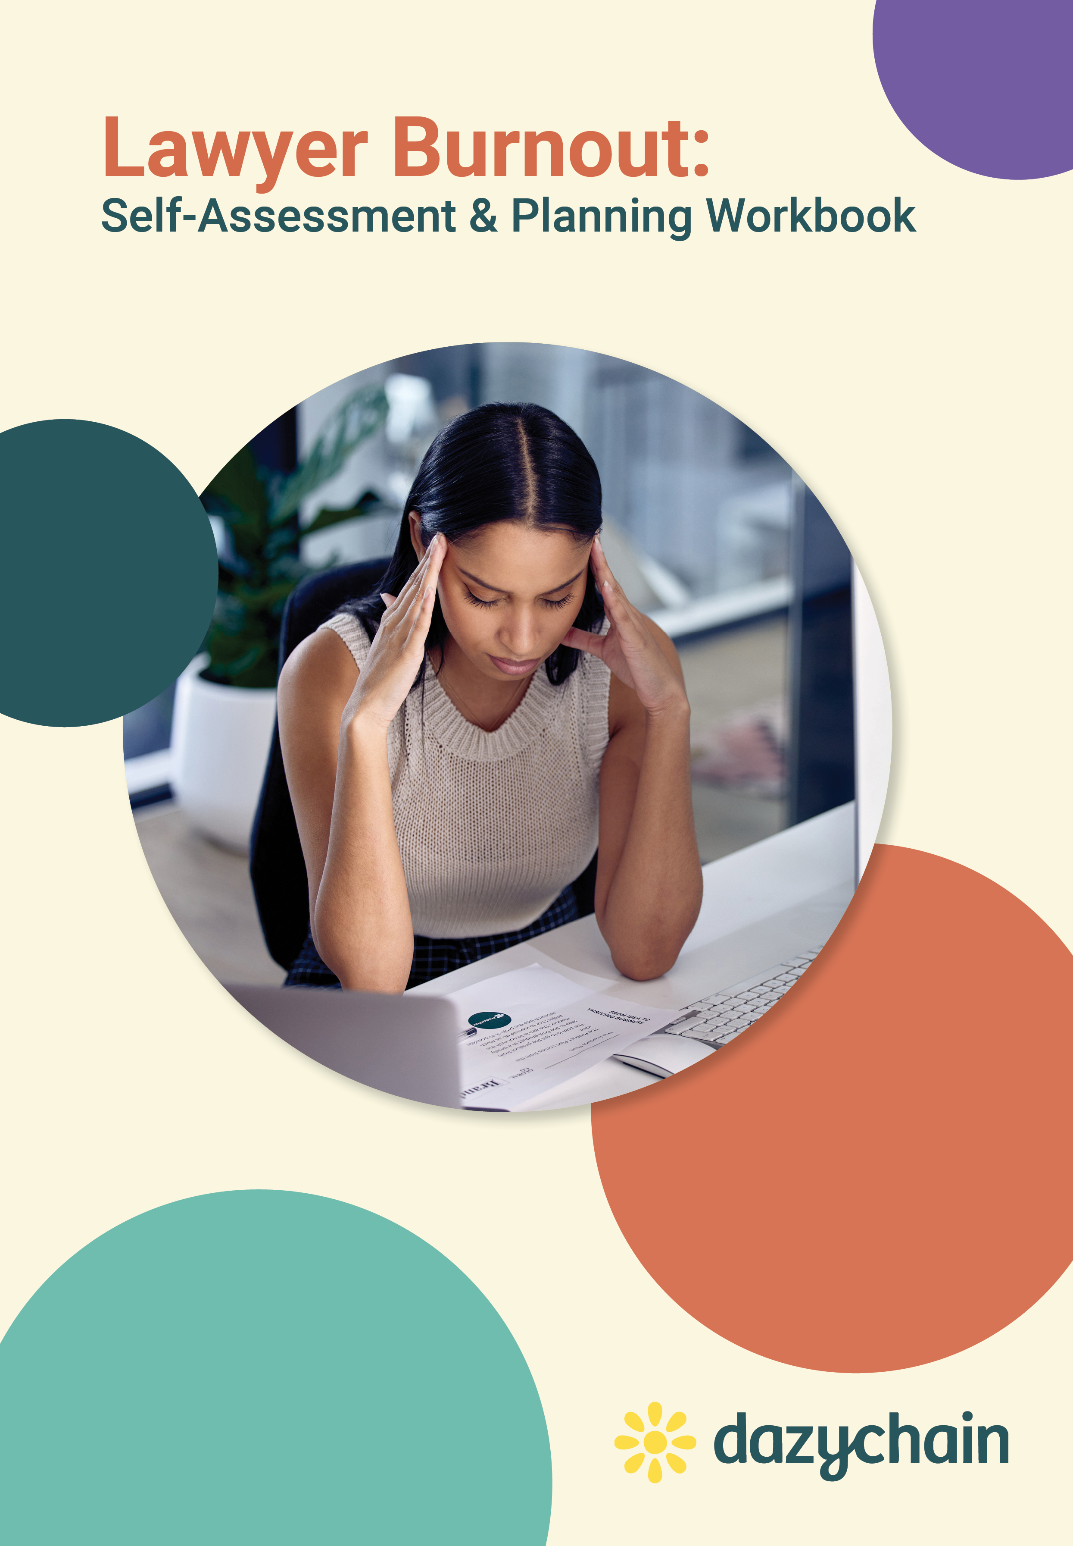

## Burnout Quiz

Do you feel drained, run down and uninterested in life? You could be burning out. Burnout happens when you’re mentally, emotionally and physically exhausted. Work, study, hobbies or relationships you used to love don’t interest you anymore.

Burning out at work can also affect your health. You might get sick more often or have changed eating and sleeping patterns. Circle your answers to this quiz below to help you reflect and identify if you’re at risk of burning out.

**1. In the past 3 weeks, how often have you felt run down and drained?**

1.) Most of the time 2.) Sometimes 3.) Rarely

**2. Do you feel that you’ve been performing at your best at work?**

1.) No 2.) Sometimes 3.) Yes

**3. Do you feel motivated to do well at work?**

1.) No 2.) Sometimes 3.) Yes

**4. In the past 3 weeks, how often have you been excited about the future?**

1.) Rarely 2.) Sometimes 3.) Most of the time

**5. Are you easily irritated by small problems?**

1.) Yes 2.) Sometimes 3.) No

**6. In the past 3 weeks, how often have you felt underappreciated or misunderstood?**

1.) Most of the time 2.) Sometimes 3.) Rarely

**7. Do you feel fulfilled by your work?**

1.) No 2.) Sometimes 3.) Yes

**8. Do you feel fulfilled by your hobbies?**

1.) No 2.) Sometimes 3.) Yes

**9. Do you feel fulfilled by your relationships?**

1.) No 2.) Sometimes 3.) Yes

**10. Are you spending too much time on your phone?**

1.) Yes 2.) Sometimes 3.) No

## Burnout Quiz results

**Mostly threes? You are probably coping well right now**

You seem to be coping well right now, and that’s awesome! It’s important to regularly check in with how you’re coping with life and do what works for you to be happy and well. For example:

* **Check in with work-related stress.** It’s easy to get caught up with the demands of work and school. If you ever feel that your motivation is decreasing or things are feeling ‘out of your control’, it’s important to identify early why that is so you can improve them.
* **Prioritize physical health.** Eating healthy meals, exercising regularly and getting enough sleep are good building blocks for you to feel the best that you can.
* **Connect with loved ones.** Meaningful social interactions help you to recharge and feel connected to the world around you.
* **Keep up with hobbies and self-care.** Regularly doing activities you enjoy can help reduce stress and encourage a positive mindset.

**Mostly ones and twos? You could be burning out soon…or now**

Dealing with the stress of work, family demands, health, community responsibilities, social change and many other stresses can lead you to burn out over time.

It’s common to get stuck in a cycle where you aren’t motivated by life, but you feel like you don’t have the energy to make positive changes.

You’ve taken the first step and have recognized that you could be burning out. It might be challenging, but from here, there are things you can do to overcome this and feel better.

If you aren’t enjoying parts of life, think about what’s working and what isn’t, and how you could improve them. For example:

* **Work:** Does your work feel rewarding? You could chat with your manager about what you could do to make your work more enjoyable or to decrease the pressure on you a bit while you figure out what's going on.
* **Relationships:** Are you getting enough meaningful social interaction? Connect with friends and family members you trust - just a simple chat can sometimes help you feel a bit better.
* **Hobbies:** Are you doing activities outside of work that you enjoy? Try to schedule time for hobbies that you enjoy every week.
* **Lifestyle:** Are you getting enough time to relax and recharge? If there are commitments that take up time and are draining, you could put them on pause to give yourself more time to yourself.

## 

## What are the signs and symptoms of burnout?

Long-term stress is exhausting and can prevent you from taking part in activities that you normally really enjoy or find meaningful. This is emotional burnout. Some of the signs of burnout include:

* Feeling exhausted and unable to perform basic tasks
* Losing motivation in many aspects of your life, including your work, hobbies or relationships
* Feeling unable to focus or concentrate on tasks
* Feeling empty or lacking in emotion
* Losing your passion and drive
* Being easily irritated by small problems
* Experiencing conflict in your relationships with co-workers, friends and family
* Emotionally withdrawing from friends and family.

Essentially, when you've reached the point of burnout, it can feel like you’ve had the life sucked out of you. You no longer feel capable of caring about what’s important to you, or making any effort, or staying motivated.

## 

## What causes burnout?

Burnout often isn’t caused by just one thing, such as a stressful job or too many life responsibilities. It’s often the result of a combination of things, including how you’re spending your downtime and how you view the world.

**Work-related causes** of burnout can include:

* Working in a high-pressure or disorganized environment
* Doing work that you don’t find exciting or challenging
* Having unrealistic expectations placed on you
* Not being recognized or rewarded for your good work
* Feeling like you have little or no control over your work

**Lifestyle-related causes** of burnout can include:

* Taking on too many responsibilities, including carer responsibilities
* Not getting enough sleep
* Not having enough time to relax and recharge  
  Not having enough close, meaningful relationships
* Not meeting your own unique needs (e.g. you’re spending too much time socializing, when you really want more time alone)

**Personality traits and your mindset** can also contribute to burning out. These traits can include:

* Perfectionist tendencies
* A pessimistic view of the world and of yourself
* Always wanting to be in control
* Feeling unable to set boundaries and to say ‘no’ to things you don’t want to do

## What’s the difference between burnout and depression?

Burnout and depression have some similar symptoms, so it can be tricky knowing how to tell the two apart. For example, both involve having less energy and motivation, and feeling more negative. Here are some tips to help tell the difference between burnout and depression:

* Being burnt out is generally associated with being too busy and overworked.
* If you feel negative about work or study, but positive about other areas of your life, this is probably burnout, not depression.
* Depression can happen at any time, and there isn’t always a clear reason why.
* Someone who is depressed feels low on more days than not for at least a couple of weeks.
* Symptoms like thoughts of suicide are more likely to be a sign of depression.

Keep in mind that these resources can’t give you a diagnosis. If you’re still unsure or you think you may have depression, you need to get more information and advice from a medical professional.

## What's the difference between burnout and stress?

* Stress puts a lot of pressure on the body. This can be manageable in the short term, and may even be beneficial in small doses.
* However, if the stress is constant, it can be bad for both your physical health and your emotional wellbeing.
* Eventually, too much stress on your body over a long period of time can cause you to burn out.
* Burnout is a state of complete mental, physical and emotional exhaustion.

## 

## What can I do about burnout?

If you’ve recognized that you’re burnt out, or on your way to burning out, you’ve taken the first step. The next step is to undo some of the damage and start managing your stress levels.

### 

### Lean on others for support

Talking to people you trust can be a great way to start figuring out what you’re going through. They could be a friend, family member, religious or spiritual leader or teammate. Whether it’s to talk through how you’re feeling, or just to connect with a loved one and take your mind off things, talking to someone can help you to start feeling better.

Of course, you could also talk with a health professional such as your doctor or a psychologist.

### 

### Prioritize your physical health

It’s easy to forget to do some basic things that can make a world of difference to how you feel. Keeping yourself physically healthy can help you to think more clearly and to manage stress better. Try these ways to improve your physical health:

* **Get the recommended six to eight hours of sleep a night.** The amount of sleep that works best for you will depend on your needs and lifestyle.
* **Eat healthy meals, with plenty of fresh fruits, vegetables and protein.** When you get busy, it’s easy to resort to living on takeout or microwaveable foods. You could try preparing meals in advance or learning to cook a few simple dishes that you can fall back on. Eating healthily doesn’t mean you can’t treat yourself! It just means that you’re more conscious of what your body needs in order to feel well.
* **Make time to exercise.** Being physically active can recharge you, help you to sleep better and improve your overall wellbeing. Exercising doesn’t mean that you have to spend hours on a treadmill – you can find an activity that you enjoy! This could be hiking, a team sport, a gym class or even a home dance workout.

### 

### Identify your early warning signs

After you’ve reversed some of the effects of burnout, you could try to figure out what your early warning signs for burnout are. That way, you can get ahead of it in the future and minimize how much it impacts you.

For example, you could ask yourself:

* Were there any hobbies that you let go of when things got busy?
* Did you experience any physical signs of stress, such as trouble sleeping or concentrating, or forgetting things?
* When you first started feeling drained, what areas of your life suffered first? Maybe you weren’t motivated to perform with your work or study, or did you have trouble keeping up with texting friends?
* Were you more pessimistic or more easily irritated by small things?
* Did you have increased conflict with friends, family or co-workers?

### 

## 

## 

## Reducing burnout: what’s important to me?

Take some time to re-evaluate your goals and priorities, so that you can tip the balance to include activities that make you feel happy.

**Instructions:**

* Read the list of your current activities in the left column below
* Add other activities that are important to you
* Consider the importance of the activity and how good it makes you feel
* Decide if you are making enough time for these activities?

|  |  |  |  |
| --- | --- | --- | --- |
| **My current activities** | **How important is this to me?**  1 = very / 5 = not | **How good does it make me feel?**  1 = very / 5 = not | **Am I making enough time for this?**  Yes / No |
| Family time |  |  |  |
| Work |  |  |  |
| Study |  |  |  |
| Community activities |  |  |  |
| Hobbies |  |  |  |
| Socializing |  |  |  |
| Exercising |  |  |  |
| Home maintenance |  |  |  |
| Vacations |  |  |  |
| Religious/spiritual activities |  |  |  |
|  |  |  |  |
|  |  |  |  |
|  |  |  |  |
|  |  |  |  |
|  |  |  |  |
|  |  |  |  |

After figuring out what activities are important to you or make you feel good, you can look at what you’re currently doing and make changes to do more of those things.

### 

### 

## Reducing burnout: simple things I can commit to now

### 

### Set a boundary

One way to avoid overextending yourself is to learn how to say ‘no’ to things you don’t want to do or that you’re unsure about. Whether it’s a time commitment or some kind of emotional discomfort or distress, continually doing things you don’t want to do can contribute to burnout.

Here are some tips on saying “no”:

* Be direct, such as “no, I can’t” or “no, I don’t want to.”
* Don’t apologize and give all sorts of reasons.
* Don’t lie. Lying will most likely lead to guilt—and remember, this is what you are trying to avoid feeling.
* Be polite, for example, saying, “Thanks for asking.”
* Practice saying no. Imagine a scenario and then practice saying no either by yourself or with a friend.
* Don’t say, “I’ll think about it” if you don’t want to do it. This will just prolong the situation.

**Name one activity, thing or person you need to say “no” to?**

_________________________________________________________________________________________

### Find a creative outlet

Creativity can be a powerful way to take care of yourself and boost your overall well-being. If you find an activity you enjoy that’s unrelated to work or study, you’ll have something to do where there isn’t any pressure to perform. The only expectation is that you have fun!

This could be any activity where you build or create something – for example:

* Gardening
* Creating art
* Playing games
* Singing/playing music
* Community activities
* Cooking/baking

**What is one activity you could start or restart that might bring you joy?**

__________________________________________________________________________________________________

### 

### Accept things that aren’t in your control

Accepting there are some things you can’t control may be challenging. Identifying when something isn’t in your control can help you to accept it. It doesn’t mean that you’re giving it a big ‘thumbs up’ – it just means that you can move on and not let it affect you too much. Once you do that, you feel better and can channel that energy into things you care about.

**What is one thing that is not in your control that you might be able to let go of?**

__________________________________________________________________________________________________

## Some recent resources and articles

Why women in midlife are fried. Apple News by Lisa Lombardi

<https://apple.news/A2TYQObnWTe2hAWYgjQuZNw>

How to beat burnout without quitting your job. New York Times by Catherine Zuckerman

<https://www.nytimes.com/2021/04/30/well/workplace-burnout-advice.html>

What burnout really means, and what bosses and employees can do about it. Washington Post by Anglea Haupt

<https://www.washingtonpost.com/lifestyle/wellness/burnout-prevent-recover-work-advice/2021/06/14/d897dc1a-cd4c-11eb-8014-2f3926ca24d9_story.html>

'Overwhelming' exhaustion: COVID leaves 66% of working parents burnt out. USA Today by Wyatte Grantham-Phillips

<https://www.usatoday.com/story/life/health-wellness/2022/05/07/covid-19-pandemic-parents-burnout/9688676002/>

The future of work is here, employee burnout needs to go. CNBC by Alicia Doniger

<https://www.cnbc.com/2021/09/23/the-future-of-work-is-here-employee-burnout-needs-to-go.html>

Burnout and stress are everywhere. American Psychological Association Monitor of Psychology by Ashley Abramson <https://www.apa.org/monitor/2022/01/special-burnout-stress>

Surveyed lawyers report burnout in their jobs more than half the time. ABA Journal by Debra Cassens Weiss <https://www.americanbar.org/groups/journal/articles/2022/surveyed-lawyers-report-they-experience-burnout-in-their-jobs-mo/>

Analysis: Attorney Well-Being Declines, With Burnout on the Rise. Bloomberg Law by Karen Miller-Kuwana and Linda Ouyang

<https://news.bloomberglaw.com/business-and-practice/analysis-attorney-well-being-declines-with-burnout-on-the-rise>

Scholarly articles on burnout  
[https://scholar.google.com.au/scholar?as_ylo=2022&q=articles+on+burnout+syndrome&hl=en&as_sdt=0,5&as_vis=1](https://scholar.google.com.au/scholar?as_ylo=2022&q=articles+on+burnout+syndrome&hl=en&as_sdt=0,5&as_vis=)